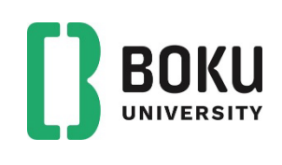

Monday 2. February 2025 at 10:00 in the seminar room of Institute of Forest Ecology/BOKU we have the pleasure to listen to:

Professor Henrik Brinch-Pedersen
(Aarhus University, Department of Agroecology
- Crop Genetics and Biotechnology)
Digital PCR aided direct root biomass determination and species profiling in soil samples

Institute of Forest Ecology (IFE)
seminar room: 02/10
Wilhelm-Exner-Haus
Peter-Jordan-Straße 82
1190 Wien

Contact:
http://www.wabo.boku.ac.at/ife.html
Host: Dr. Katarzyna Retzer, katarzyna.retzer@boku.ac.at

